Topic – Are You Wise? Healthwise
TASK 1: How does your pulse rate / heart rate vary when undertaking 30 seconds of different types of exercise?
- Dribbling a ball around the garden (football or basketball style)
- Aerobics (star jumps or burpies or step ups)
- Walking
For this activity you will need
- Stopwatch (on a phone)
- Pencil and paper (Maths exercise book)
- A ball
- An adult to help
You will also need to be able to take your pulse, so you might want to practise and maybe get somebody to help you!!
Remember also to give yourself time to recover from the previous exercise before you start the next activity.
You can use the table below or design your own to record results.
 | Activity 1:
Pulse rate / heart rate BEFORE exercise  (beats in a minute) |  | Pulse rate / heart rate AFTER exercise  (beats in a minute)
 | Activity 2:
Pulse rate / heart rate BEFORE exercise  (beats in a minute) |  | Pulse rate / heart rate AFTER exercise  (beats in a minute)
 | Activity 3:
Pulse rate / heart rate BEFORE exercise  (beats in a minute) |  | Pulse rate / heart rate AFTER exercise  (beats in a minute)

TASK 2: Reflecting on the task, analysing your results and making conclusions.
1. How did you manage trying to find your pulse rate?
2. Where did you take your pulse rate from?
3. Which was the most and least strenuous form of exercise? How do you know?
4. What did you notice about your pulse/heart rate when you undertook the different forms of exercise?
5. Can you think of another form of exercise that you think would make your pulse rate greater than your highest recorded result?
6. What was the most challenging part of the task?
7. If you were asked to repeat the task at a later date, what would you do differently to ensure your recording s were as accurate as possible?

TASK 3: How to Keep our Bodies Healthy

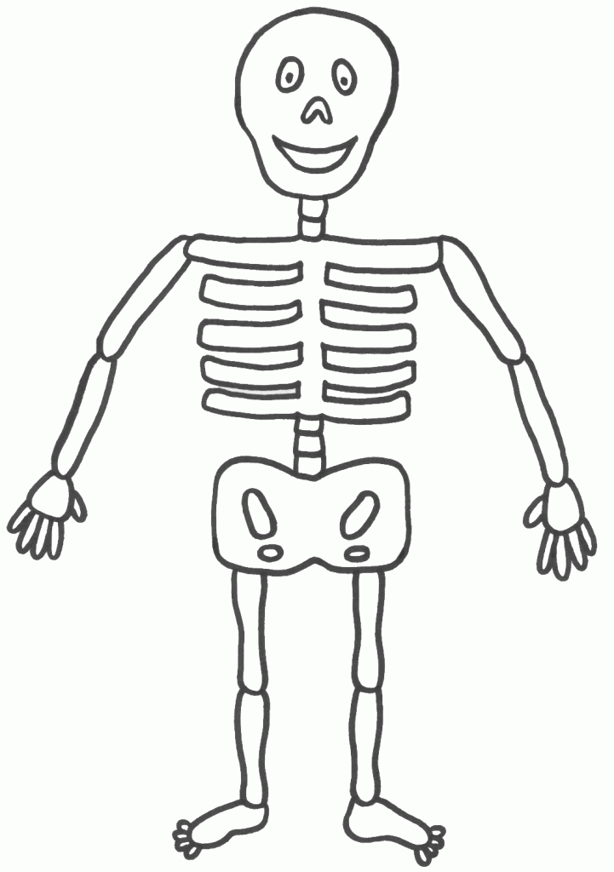
Research and make a list of particular foods we can eat and things we can do (or NOT do) to keep different parts of our bodies healthy. (You can record this into your writing book)
Part of our Body | Foods to Eat | Things we can do/not do
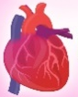
Heart
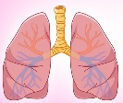
Lungs
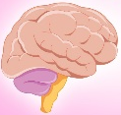
Brain
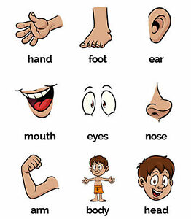
Eyes
Bones
Mouth
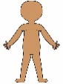
Skin
Stomach

