School Information for Parents/Guardians
Monday 14 October 2024

Follow us now on the web for news updates
www.stbrigidspsballymoney.com

NUT FREE SCHOOL
St Brigid’s PS is a Nut Free School. There is a child in our school with a Nut Allergy.
Please do not send in Nuts or Nut Spreads to school.
Sacrament Dates 2024-25
Sacrament of Penance: (Year 3)
Thursday 27 March 11.00am
Sacrament of Confirmation: (Year 7)
Friday 11 April 10.30am
Sacrament of Communion: (Year 4)
Saturday 31 May 10.30 am

Monday 14 October
ASDA CASHPOT
FOR SCHOOLS
Amount raised so far
£135.92
Thank you
- New Dinner menu Week 2 – for details see school website.
- Violin Tutor in
- Year 7 visiting Loreto (school show).
- Year 6 Library visit
Tuesday 15 October
- Swimming Class B (1.00-1.30pm) and Year 5 (1.30-2.00 pm) £3.50 per week
- Guitar Tutor in
- Year 4 visit to Ballymoney Museum
Wednesday 16 October
- Year 4 Multi-Sport: (5 weeks - £2.00 per week or £10.00 for 5 weeks)
- Year 5/6/7 & CB – Gaelic Skills
- Singing Tutor in
Thursday 17 October

Friday 18 October
- Principal Awards
- Piano Tutor in
- Football 2-3pm (Y6 & 7) £1 per week
Up and coming information & dates for your Diary
After School Childcare – Spaces available!!!
- Sunshine Club: 2.00 – 3.00 pm (£2) 3.00 – 5.30 pm (£2 per hour or part thereof)
- Breakfast Club: 8.00 – 9.00 am (£2 per day)
- Halloween Disco – Thursday 24 October
- Mid Term Break October/November 2024:
Monday 28 October to Friday 1 November (inclusive)
Christmas Break 2024:
12 noon Friday 20 December – Friday 3 January (inclusive)

Have a very enjoyable weekend and thanks for your continued support.

Mr K O’Neill Principal
St Brigid’s Primary School – Castle Street – Ballymoney – BT53 6JX – 028 27662664

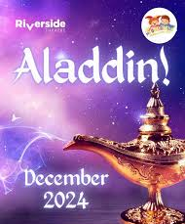
School Trip to the Riverside Theatre
Aladdin
Tuesday 3 December 2024
Whole School
Cost £14.50 per pupil
Payment can be made in instalments to spread the cost over next 10 weeks. Payments can be made at any time. Just send money into the school clearly marked for the attention of the class teacher.

Parent Interviews
Year 2, 3, 4, 5, 6, 7, CA & CB

Parent interviews will take place during the week beginning 21 October 2024

School will close each day this week at 1.00pm.

A form was issued to allow parents to give a first and second preference of days for the interviews. If a preference was not requested by Tuesday 8 October, a time will still be allocated by the class teacher.
All interviews will be an in-person meeting with the class teacher this year.
Interview times will be sent out during week beginning Monday 14 October.

Each interview will be no more than 10 minutes.

During the week of Parent Interviews, the school will close at 1.00 pm for all children each day.
Due to the yellow bus having to deliver school meals, it will not be available to collect children at 1.00pm when the school closes for parent interviews. Please make alternative arrangements to have your child picked up at 1.00pm each day this week (Mon-Fri).
There will be no CB or Year 5 swimming during this week.
The After School Club will be open as normal from 1 – 5.30 pm. Pre-booking only - no casual drop-ins.
The October booking form is available on the school website along with the After-School Agreement that must be signed.

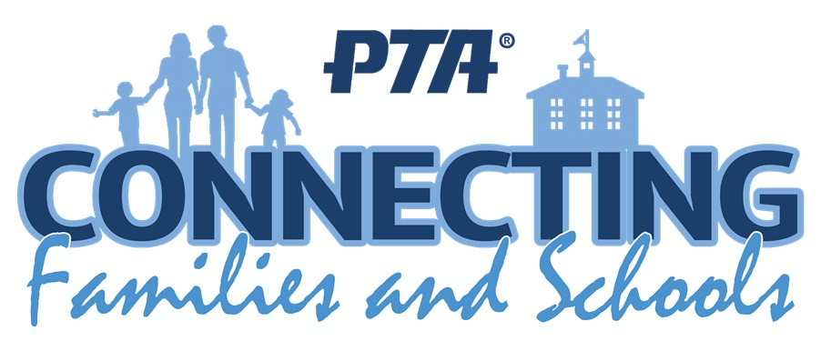
PTA Meeting
It was agreed at the meeting that there would be a change to the events this year. The Christmas event will be replaced by a Summer Fair this year in June. There will still be a Christmas Draw and several other in school Christmas events.
A form to indicate a willingness to help at events will be sent to all parents next week.

DO THIS IN MEMORY
Once again, we will be having a monthly Mass for young children and their families this year with a special invitation to those who will be making their First Communion next spring. The first Do This In Memory Mass will be at 9.30am on Sunday October 20th. After Mass we invite all primary school aged children and their parents to join us in the parish hall for craft activities (and a cup of coffee for the parents!)
Christmas and Spring Shows 2024/25
Year 1-3 & CA will be doing a Christmas Show on Thursday 12 December at 10am followed by refreshments for all attending. Year 4-7 & CB will be doing a Spring Show again this year. More details to follow at the beginning of Term 2.
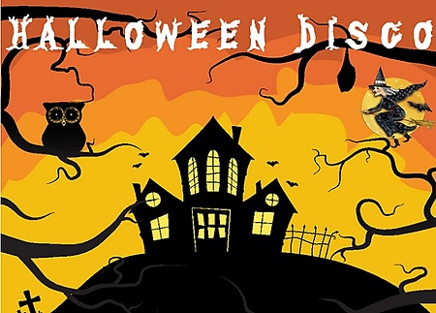
Thursday 24 October
Y1-3 6.15 - 7.15 pm
Yr4-7 7.30 - 8.30 pm

