School Information for Parents/Guardians
Monday 24 February 2025

Follow us now on the web for news updates
www.stbrigidspsballymoney.com

Confirmation 2025
Friday 11 April 2025 at 10.30 am in Our Lady and St Patrick’s Church
School is closed to all pupils on this day.
Confirmation children and the school choir to come into school between 10 and 10.15 am.
There will be refreshments back in the school for all after the Service of Confirmation.

Sunday 23 Febraury
- Year 4 Holy Communion Class: Do This in Memory Sunday Mass 9.30 am
Monday 24 February
NUT FREE SCHOOL
St Brigid’s PS is a Nut Free School. There is a child in our school with a Nut Allergy.
Please do not send in Nuts or Nut Spreads to school.
- New Dinner menu Week 2 – for details see school website.
March Milk
£3.99
Order before
Tuesday 25 February
Tuesday 25 February
- Violin & Guitar Tutor in
- Swimming Class B (1.00-1.30pm) and Year 6 (1.30-2.00 pm)
£3.50 per week
Wednesday 26 February
- Class B Council Sport: (5 weeks - £2.00 per week or £10.00 for 5 weeks)
- Singing Tutor in
Thursday 27 February
- Girls’ Score Cup 5-a-side @ Score 9.15 am – 12.30 pm
Friday 28 February
- Netball Practice
- Piano Tutor
- Football 2-3 pm (£1 per week/£10 for 10 weeks)
Up and coming information & dates for your Diary

- Tuesday 18 March: NI Girls’ Hockey Qualifiers – Team meeting at school 9.00 am
- St Patrick’s Holiday:
Monday 17 & Tuesday 18 March – St Patrick’s Day
Confirmation Day:
Friday 11 April – School Closed to all pupils (Year 7 and Choir to attend)
Easter Break 2025:
12 noon Thursday 17 April – Friday 25 April (inclusive)

Have a very enjoyable weekend and thanks for your continued support.

Mr K O’Neill Principal
St Brigid’s Primary School – Castle Street – Ballymoney – BT53 6JX – 028 27662664
Sacrament Dates 2024-25
Sacrament of Penance: (Year 3)
Thursday 27 March 11.00am

Service of Light: (Year 7)
Wednesday 26 March 7.00pm

Sacrament of Confirmation: (Year 7)
Friday 11 April 10.30am

Sacrament of Communion: (Year 4)
Saturday 17 May 10.30 am

Sacrament of Penance
Thursday 27 March 2025
Reminder: To confirm Baptism details, please remember to complete the form sent out to parents. If your child was baptised in a parish other than Our Lady and St Patrick’s, Ballymoney, you will need to request a Baptism Certificate from that parish and send it in to school.

Pupil Absence

If your child is absent from school please contact the school office on the first day of absence, give the reason for absence and possible duration.
Thank you

Spring Show!
Save the Date.
Year 4-7 and Class B will present their Spring Show.
Day Show Wednesday 2nd April @ 10.30 am
Evening Show Wednesday 2nd April @ 7pm
More details following half-term.

P1 Applications 2025
Applications for a P1 place for September 2025 have now closed.
If you have missed the online deadline, you can still make a late application. Please contact the school if this is the case.

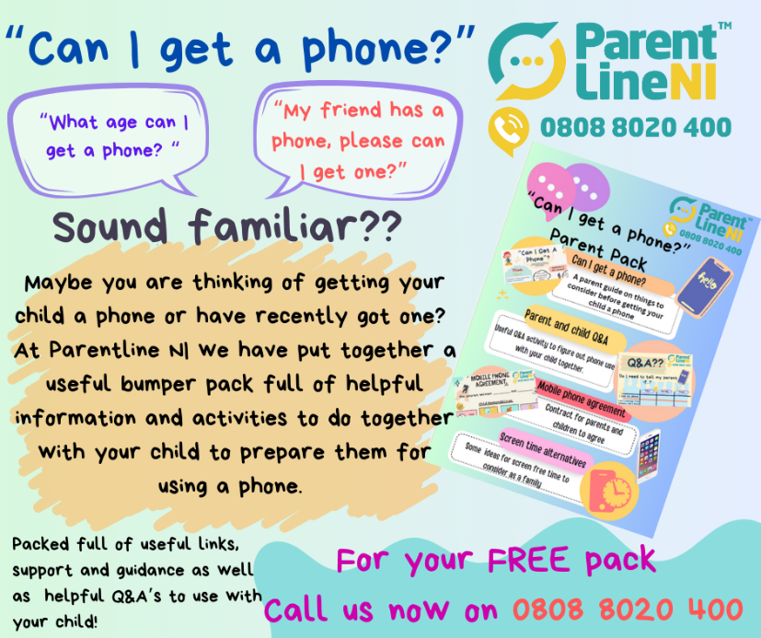
Year 4 Holy Communion Class
Do This in Memory Sundays

March 16th, 2025

April 13th, 2025

June 22nd, 2025
All at the 9.30am Mass

WORLD BOOK DAY
Thursday 6th March
Children will not dress up this year.

More details to follow on our World Book Day activities for 2025.

Term 2 Holidays
Mon 10 – Fri 14 Feb
Mid-Term Break
Monday 17 & Tuesday 18 March
St Patrick’s Day
Fri 18 – Fri 25 Apr
Easter Break

