School Information for Parents/Guardians
Monday 4 November 2024

Follow us now on the web for news updates
www.stbrigidspsballymoney.com

NUT FREE SCHOOL
St Brigid’s PS is a Nut Free School. There is a child in our school with a Nut Allergy.
Please do not send in Nuts or Nut Spreads to school.
Sacrament Dates 2024-25
Sacrament of Penance: (Year 3)
Thursday 27 March 11.00am
Sacrament of Confirmation: (Year 7)
Friday 11 April 10.30am
Sacrament of Communion: (Year 4)
Saturday 17 May 10.30 am

Monday 4 November
ASDA CASHPOT
FOR SCHOOLS
Amount raised so far
£154.18 Thank you
- New Dinner menu Week 1 – for details see school website.
- Violin Tutor in
- Year 7 Library visit

Tuesday 5 November
- Guitar Tutor in
- Cross Country Event (am)
- Swimming Class B (1.00-1.30pm) and Year 5 (1.30-2.00 pm) £3.50 per week

Wednesday 6 November
- Year 4 Multi-Sport: (5 weeks - £2.00 per week or £10.00 for 5 weeks)
- Year 5/6/7 & CB – Gaelic Skills
- Singing Tutor in

Thursday 7 November

Friday 8 November
- Piano Tutor in
- Principal Assembly
- Football 2-3pm (Y6 & 7) £1 per week

Up and coming information & dates for your Diary
- Christmas Break 2024:
12 noon Friday 20 December – Friday 3 January (inclusive)

Have a very enjoyable weekend and thanks for your continued support.

Mr K O’Neill Principal
St Brigid’s Primary School – Castle Street – Ballymoney – BT53 6JX – 028 27662664

PTA Grand Christmas Draw Prize Donation Appeal 2024
Every year we are blown away by the generosity of local businesses and parents in donating great prizes for our PTA Christmas Draw.
Last year we had almost 40 great prizes that were donated.
We begin our appeal now for support in donating a prize towards the draw.
We acknowledge the pressures businesses and parents are currently facing and we would appreciate any support you can give us this year.
If you feel you can support us, please let us know your pledge of support before Friday 15 November.
This is to give us time to get the tickets printed.
Further information about the tickets and all our other plans for Christmas later in November.


School Trip to the Riverside Theatre
Aladdin
Tuesday 3 December 2024
Whole School
Cost £14.50 per pupil
Payment can be made in instalments to spread the cost over next 10 weeks. Payments can be made at any time. Just send money into the school clearly marked for the attention of the class teacher.

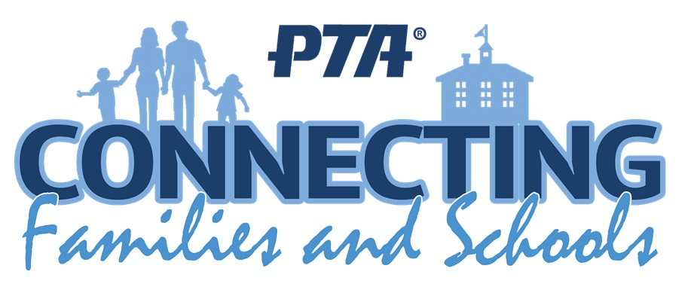
PTA Meeting
It was agreed at the meeting that there would be a change to the events this year. The Christmas event will be replaced by a Summer Fair this year in June. There will still be a Christmas Draw and several other in-school Christmas events.
A form to indicate a willingness to help at events will be sent to all parents next week.


Save the Date!!
ST BRIGID’S PS - OPEN MORNING
Registration P1 September 2025
Tuesday 28 November @ 10 am

Do This In Memory Sundays
Year 4 Holy Communion Class
November 24th 2024
December 15th 2024
All at the 9.30am Mass
Registration P1 September 2025
If you have a child starting school in September or know someone who is, please contact the school to register your interest.
Phone: 02827662664
Email: info@stbrigidsps.ballymoney.ni.sch.uk

Application process is online this year and opens on 10 January 2024 at 12noon (GMT) and closes on 24 January 2024 at 12noon


Free Kids 2km run/jog/walk in Ballymoney Riverside Park every Sunday @ 9:30am
Register FREE at www.parkrun.org.uk/register

Speed and careful driving in the Chapel car park
Please be mindful of your speed in the chapel car park when dropping off and picking up the children. The car park is busy with children moving to and from cars. All drivers must be careful. Speed limit is 10 miles per hour.

