Multiplication Mosaic
Your challenge:
• Can you use your multiplication skills to reveal the picture hidden in the grid?
How to play:
1. Work out the answer to the calculation in each square using your knowledge of the 1-12 times tables.
2. Colour in each square based on the key at the top of the sheet.
What picture will you reveal?
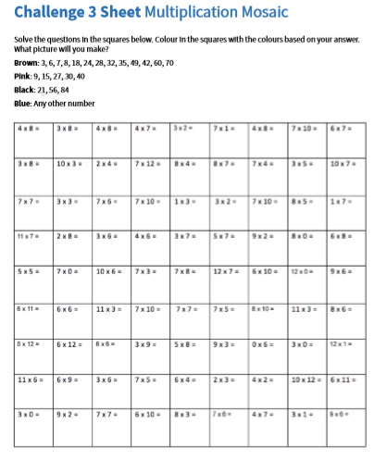
Challenge 3 Sheet Multiplication Mosaic

